**Processing Incoming Manual Payments**

**T Code:**

**Processing Incoming Manual Payments:** FPE1

**Processing Manual Payments**

Step 1: Using the above T Code navigate to the following screen and enter the required details

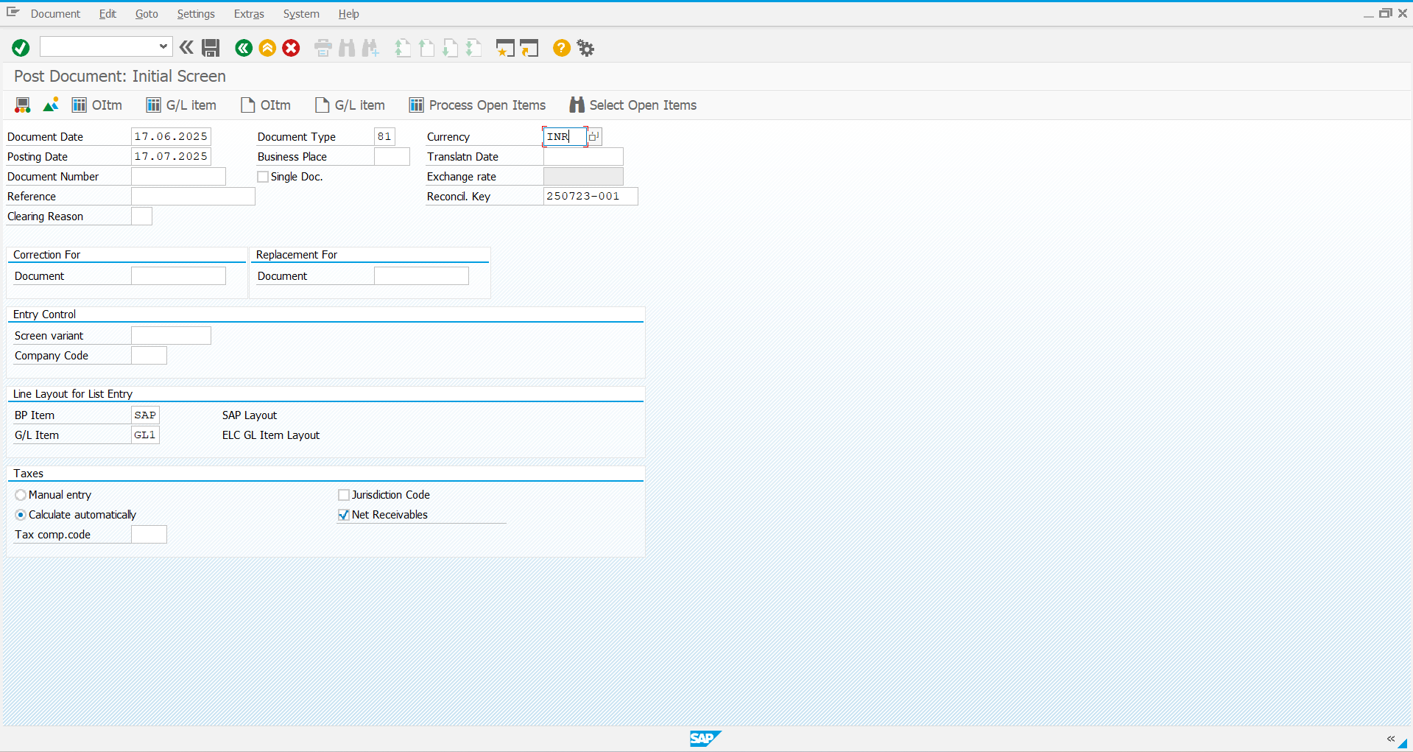

Step 2: Press enter and give the required details in the next screen and save it.

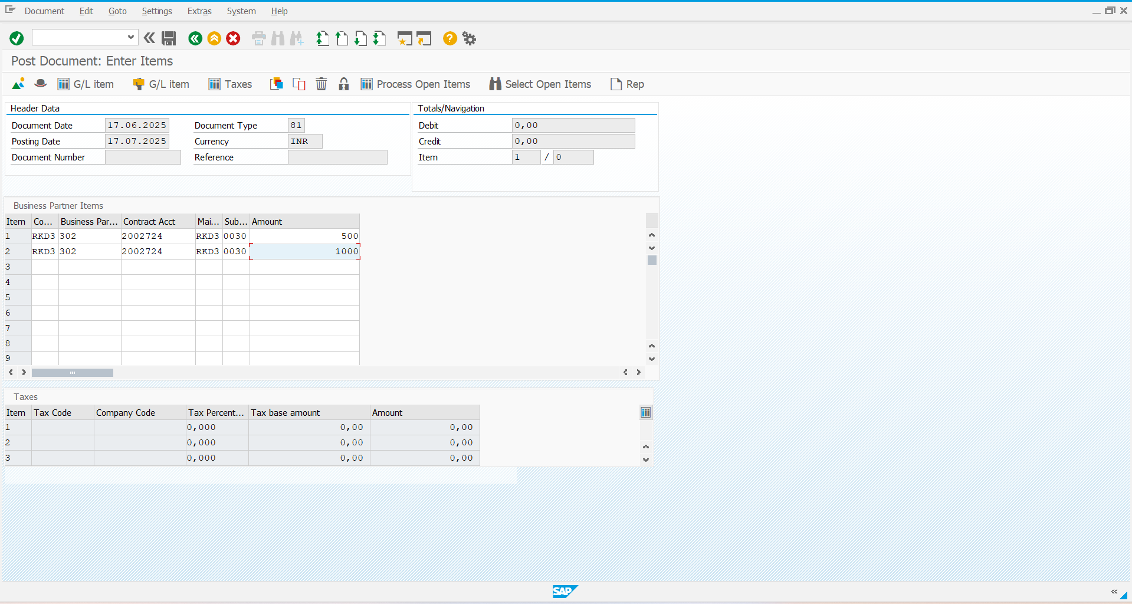

Step 3: The Document has been posted with the **DN: 2000015**

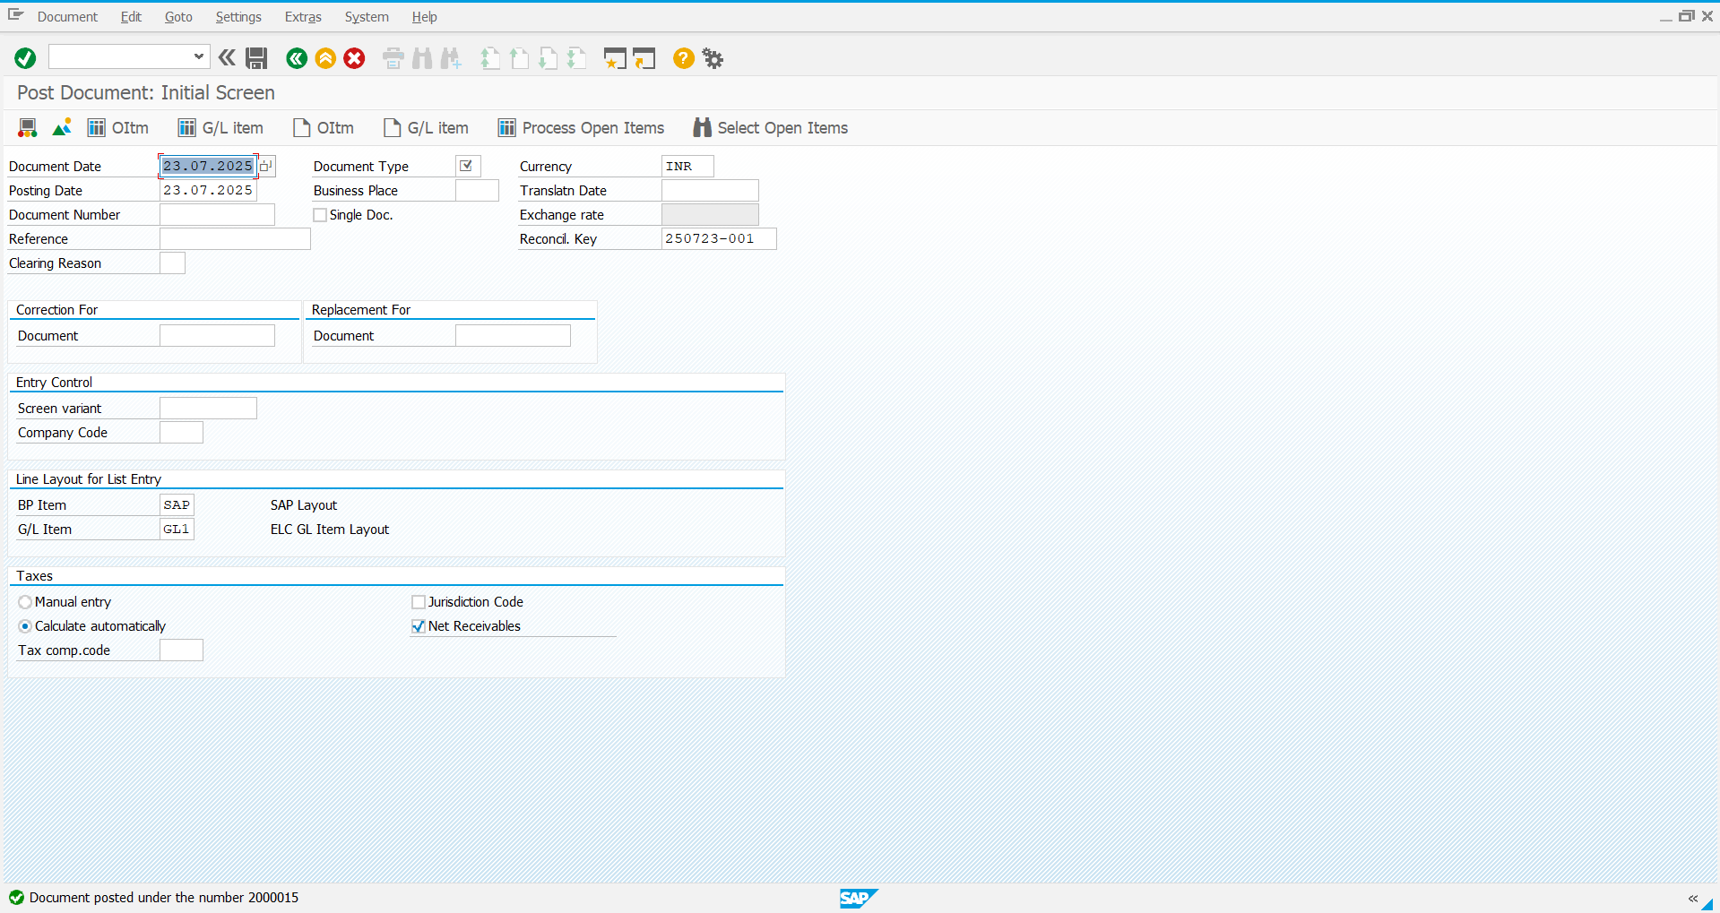

Step 4: Using the **T Code: FPL9** you can check the Account Balance

